ASSIGNMENT 05
Name: Maryam Rehan
Course: Digital Marketing
Instructor: Sir Qasim Raza
14th August Independence Day Content for Hadi E-learning
“Freedom to Learn Power to Grow”
Introduction:
14th August is a day of pride, unity, and freedom for every Pakistani. It reminds us of the struggle and sacrifices that made Pakistan an independent nation. This Independence Day, we celebrate not only our freedom but also the opportunities we have to learn, grow, and contribute to our country's future.
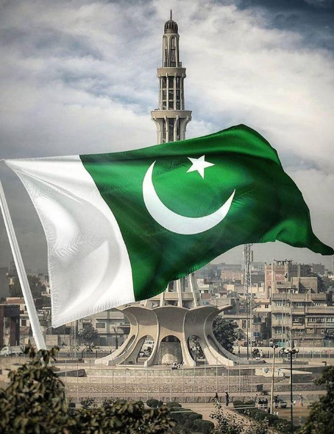
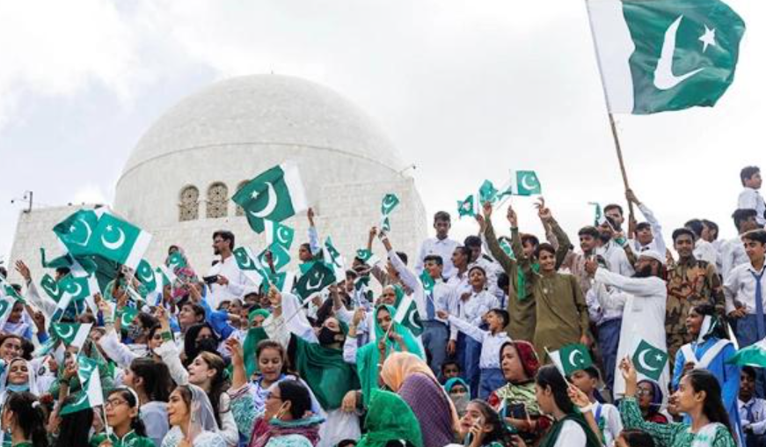
Freedom to Learn:
Freedom is not only about living independently; it is also about having the opportunity to gain knowledge and develop new skills. Education gives individuals the confidence and ability to make better decisions, discover their potential, and create meaningful opportunities for themselves.

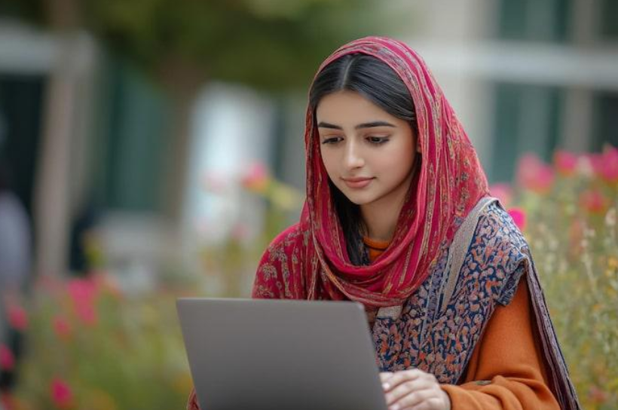
Digital Learning Education Beyond Classrooms:
Technology has transformed the way we learn. Digital learning allows students to access educational resources anytime and anywhere. Online platforms make it easier to learn modern skills, explore new subjects, and continue learning beyond traditional classrooms.
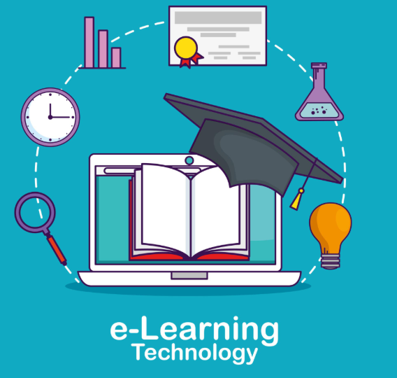
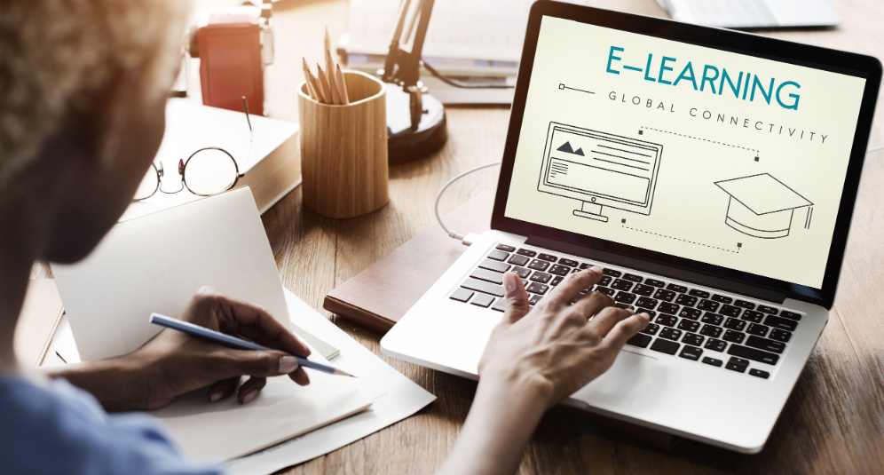
Building a Skilled Pakistan:
A country's progress depends greatly on the knowledge and skills of its people. By developing digital, creative, and professional skills, Pakistan's youth can become more confident, productive, and prepared for the future. Every new skill can become a step toward a stronger Pakistan.
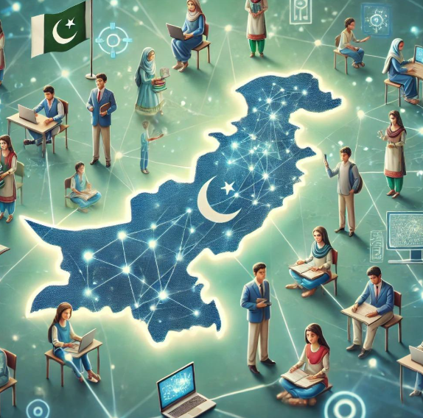
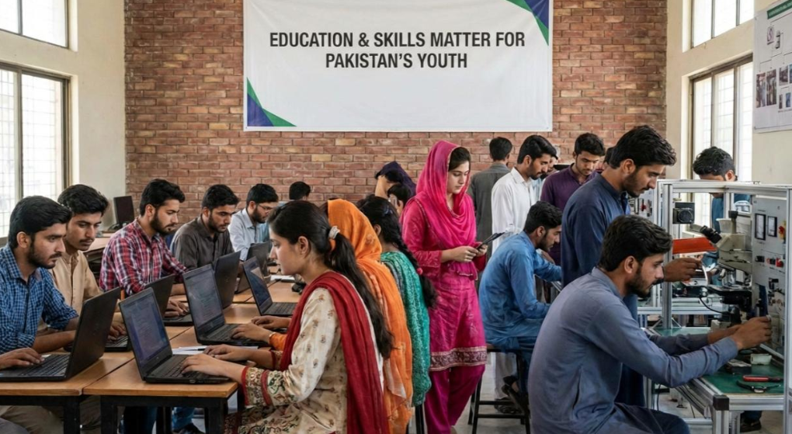
Hadi E-learning Empowering Learners:
Hadi E-learning promotes the idea that learning should be accessible, engaging, and continuous. Through digital education, learners can improve their knowledge, develop valuable skills, and prepare themselves for opportunities in the modern world.
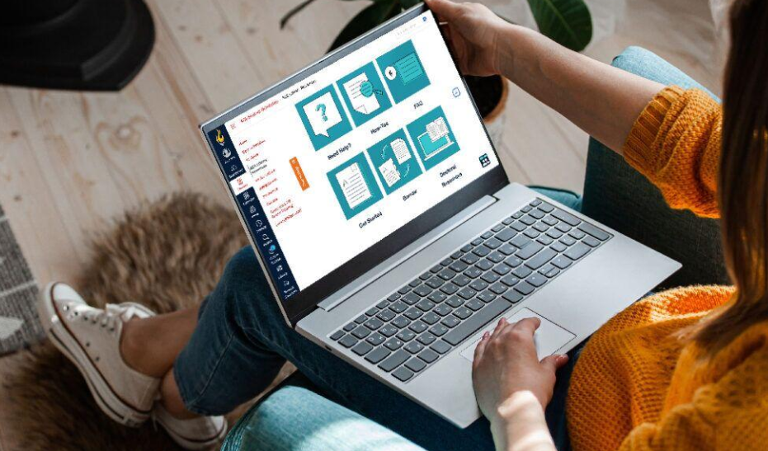


Independence Through Knowledge:
True progress begins when people have the knowledge and skills to shape their own future. Education empowers individuals to become independent thinkers, problem-solvers, and innovators. By investing in learning today, we can create a more educated and capable Pakistan tomorrow.

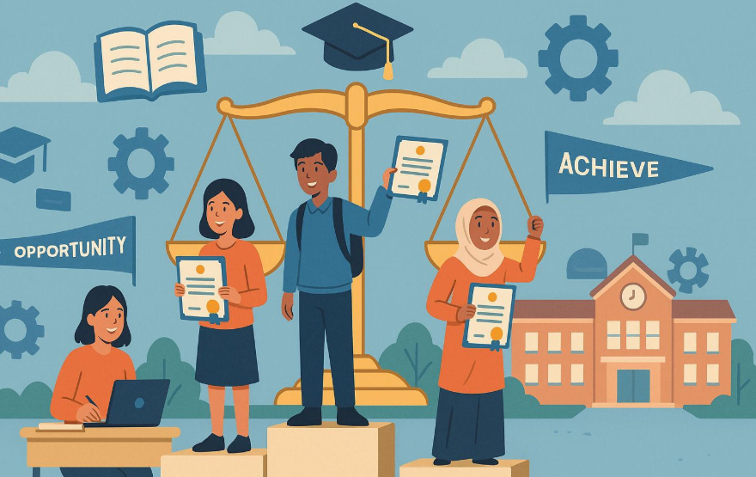
Our Independence Day Message:
This Independence Day, let us celebrate the freedom to learn, create, innovate, and grow. Let us use knowledge and technology to overcome challenges and contribute positively to our society. Together, we can turn the potential of Pakistan's youth into progress for the nation.
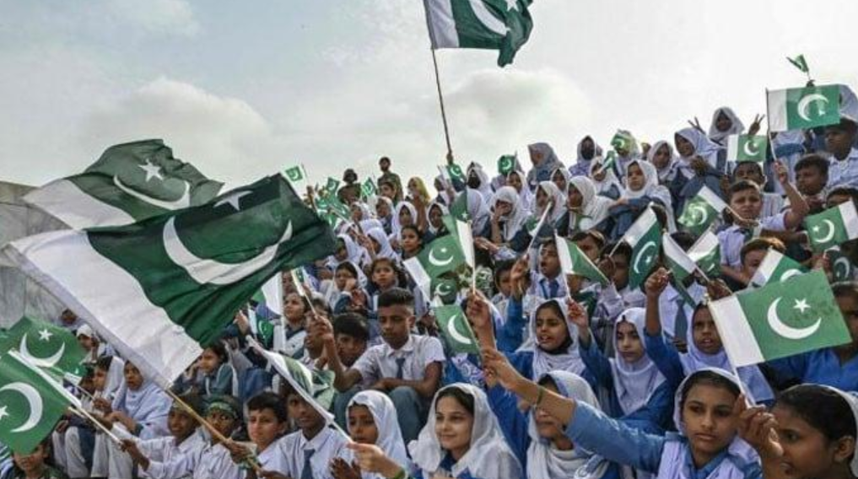

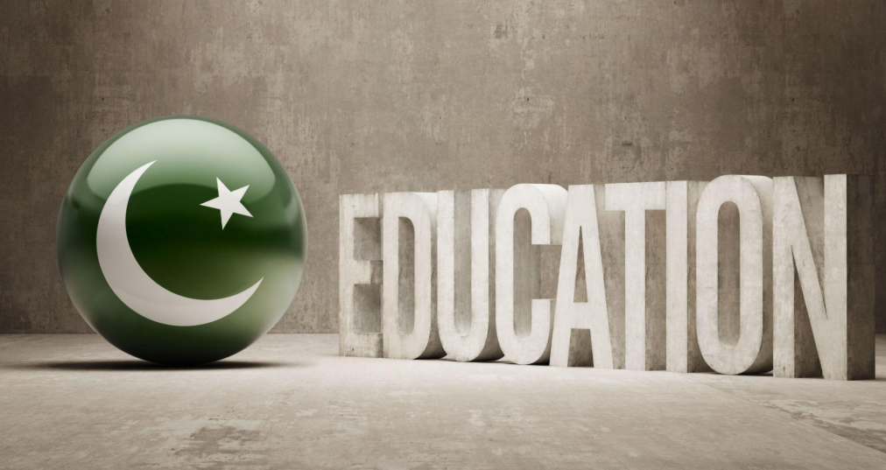
- “Freedom to Learn, Power to Grow”
- “Learn Today. Lead Tomorrow. Build Pakistan”
- “Educate Minds, Empower Pakistan”
- “A Skilled Youth, A Stronger Pakistan”
- “Celebrate Freedom. Embrace Learning”
- “Knowledge Today, Progress Tomorrow”
- “Learn More, Dream Bigger, Build Pakistan”
- “The Future of Pakistan Begins with Learning”
Commitment:
This 14th August, make a commitment to keep learning, keep growing, and keep contributing. Let every new skill become a step toward a better future for Pakistan.
Conclusion:
Independence Day reminds us that the progress of Pakistan depends on the knowledge, skills, and determination of its people. Education and digital learning give the youth the power to explore opportunities, develop their abilities, and contribute to society. Through continuous learning and innovation, we can help create a stronger, smarter, and more successful Pakistan.
“A brighter Pakistan begins with an educated and empowered generation”

